EXPERIMENT 2
Design a user interface prototype for a mobile station using Figma, considering
connectivity and convenience.
1. Aim
To design a user interface prototype for a Mobile Station using Figma, considering connectivity and convenience, with user-friendly screens for network status, nearby stations, connectivity testing, and profile settings.
2. Software Used
- Software: Figma
- Purpose: To design the mobile application UI and create an interactive prototype.
- Platform: Web-based design tool.
3. Algorithm
- Start.
- Open Figma and create a new design file.
- Create a welcome screen with the application name and Get Started button.
- Design the home dashboard to display network status, signal strength, and quick-access options.
- Create a nearby stations screen with a map, station locations, and directions.
- Design a connectivity screen to display network type, download speed, upload speed, and ping.
- Create station details and profile settings screens.
- Add buttons and navigation links between screens using Prototype mode.
- Test the navigation and verify the user interface.
- Stop.
4. Prototype
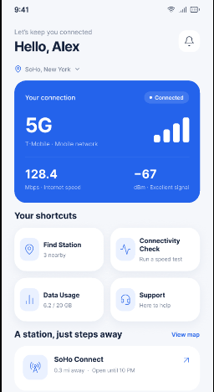
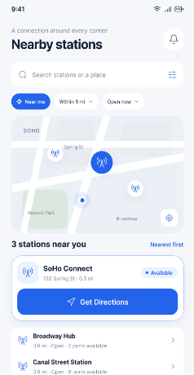
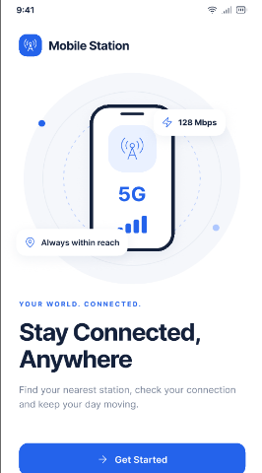

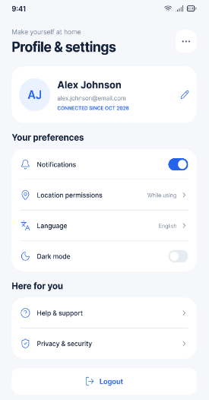
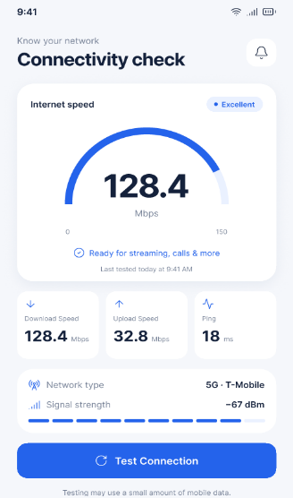
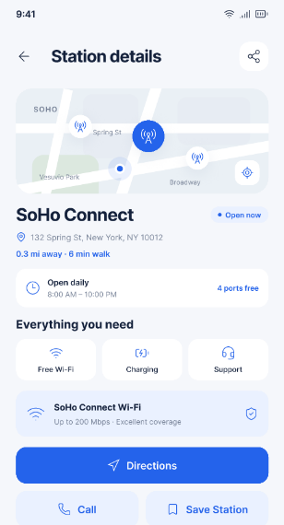

5. Design
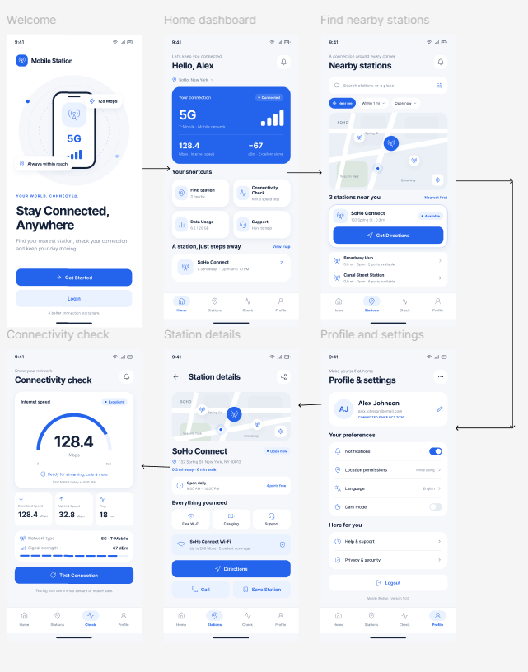

6. Result
The Mobile Station user interface prototype was successfully designed using Figma. The prototype provides a simple and convenient interface for checking connectivity, finding nearby stations, viewing station details, and accessing user settings. Interactive navigation between screens improves usability and accessibility.

